Deliverable 1:

Teamwork Summary:
Julien: I did the initial ERD design, and I helped with the creation of the revised ERD and the logical schema. I also made some final improvements after receiving teacher feedback.
Denzel:
Difficulties:
- Draw.io’s functionality can be a bit finicky at times, so we had to learn how to use it properly and efficiently.

Images of the diagrams will be submitted along with the PDF for facilitated viewing.

Diagrams:

Crows foot ERD:
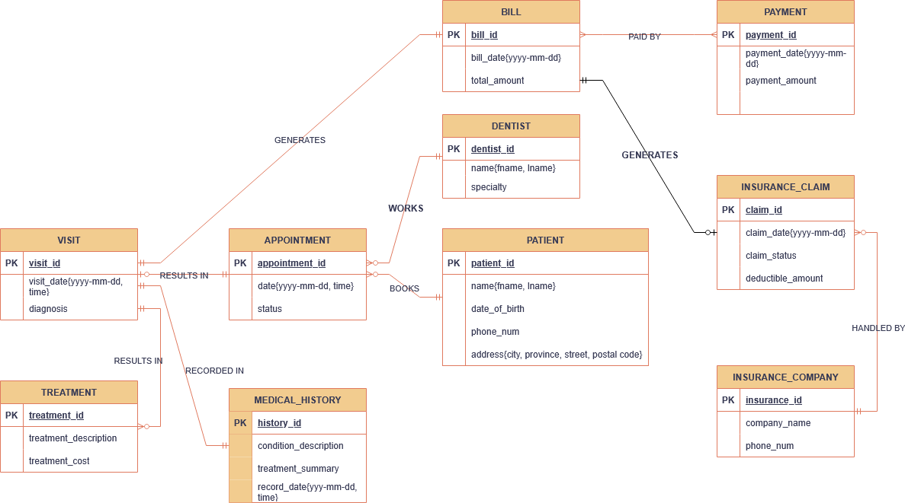

Revised ERD: 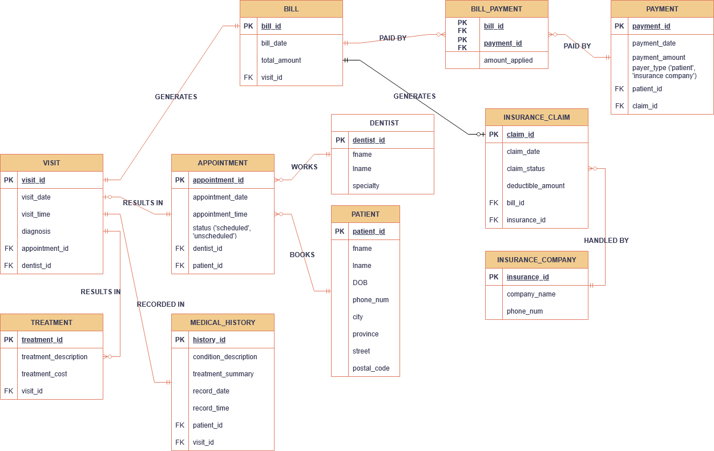

Logical Schema: 